Level 0:

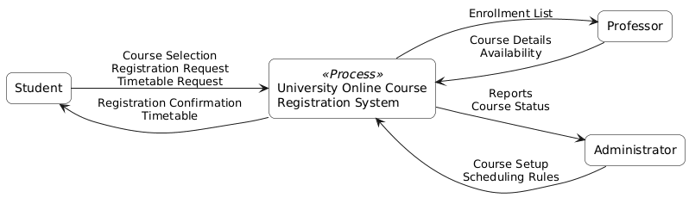

Here is a beginner-friendly explanation of the Level 0 Data Flow Diagram (Context Diagram) you shared.

What is a Level 0 DFD?
A Level 0 DFD, also called a Context Diagram, shows:
- The entire system as one single process
- The external entities that interact with it
- The main data flows going in and out of the system
👉 It does not show internal details or databases—only who interacts with the system and what information is exchanged.

The System at the Center
University Online Course Registration System
- This represents the whole system
- All processing (registration, scheduling, reporting) happens inside this box
- At this level, we don’t worry about how it works—only what goes in and out

External Entities (Who Interacts with the System)
1️⃣ Student
The Student is someone who wants to register for courses.
Data sent TO the system:
- Course Selection
- Registration Request
- Timetable Request
Data received FROM the system:
- Registration Confirmation
- Timetable
➡️ This shows that students use the system to enroll in courses and view their schedules.

2️⃣ Professor
The Professor provides and receives course-related information.
Data sent TO the system:
- Course Details
- Availability
Data received FROM the system:
- Enrollment List
➡️ This shows that professors inform the system about their courses and can see which students are enrolled.

3️⃣ Administrator
The Administrator manages and oversees the system.
Data sent TO the system:
- Course Setup
- Scheduling Rules
Data received FROM the system:
- Reports
- Course Status
➡️ This shows that administrators control how courses are set up and receive system reports.

Understanding the Arrows (Data Flows)
- Arrows going INTO the system = information provided by users
- Arrows going OUT of the system = information the system produces
- Each arrow is labeled to clearly show what data is being exchanged
Example:
- “Registration Request” → Student to System
- “Timetable” → System to Student

Why This Diagram Is Important
✅ Clearly defines the system boundary
✅ Identifies all external users
✅ Shows high-level data movement
✅ Serves as a foundation for more detailed DFDs (Level 1, Level 2)

One-Sentence Summary
This Level 0 DFD shows the University Online Course Registration System as a single process and illustrates how Students, Professors, and Administrators interact with it by sending and receiving key information.

Level1:
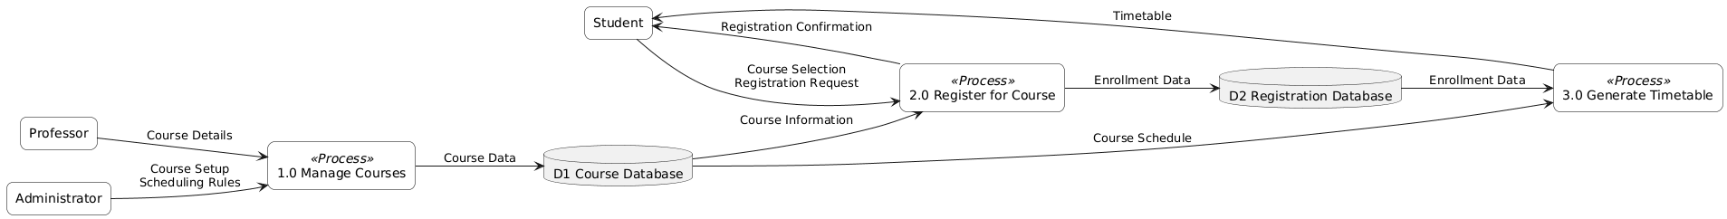
Here is a clear, beginner-friendly explanation of the Level 1 Data Flow Diagram (DFD) you attached.

What is a Level 1 DFD?
A Level 1 DFD breaks the whole system (shown as one box in Level 0) into smaller processes.
It explains how the system works internally by showing:
- Sub-processes
- Data stores (databases)
- How data flows between them
This diagram still does not show technical details like code—it focuses only on data movement.

Main Components in This Level 1 DFD
External Entities (People Outside the System)
- Student
- Professor
- Administrator
They interact with the system but are not part of it.

Processes (What the System Does)
There are three main processes inside the system:

1.0 Manage Courses
This process handles course setup and maintenance.
Inputs:
- Course Details from the Professor
- Course Setup & Scheduling Rules from the Administrator
Output:
- Course Data stored in D1 Course Database
➡️ This process ensures that all course information is properly created and updated.

2.0 Register for Course
This process handles student registration.
Inputs:
- Course Selection & Registration Request from the Student
- Course Information from D1 Course Database
Outputs:
- Enrollment Data stored in D2 Registration Database
- Registration Confirmation sent back to the Student
➡️ This process allows students to enroll in courses and confirms successful registration.

3.0 Generate Timetable
This process creates a student’s timetable.
Inputs:
- Enrollment Data from D2 Registration Database
- Course Schedule from D1 Course Database
Output:
- Timetable sent to the Student
➡️ This process combines course schedules and enrollment details to produce a personalized timetable.

Data Stores (Where Data Is Kept)
D1 Course Database
Stores:
- Course details
- Course schedules
Used by:
- Manage Courses
- Register for Course
- Generate Timetable

D2 Registration Database
Stores:
- Student enrollment data
Used by:
- Register for Course
- Generate Timetable

Understanding the Data Flow
- Data always flows through a process
- External entities never access databases directly
- Each process has at least one input and one output
- Arrow labels describe what data is moving
Example:
- Student → Register for Course → Registration Database
- Registration Database → Generate Timetable → Student

How This Connects to Level 0 DFD
✔ Same external entities (Student, Professor, Administrator)
✔ Same system scope
✔ Level 1 simply adds more detail
This is called balancing and is required for correct DFDs.

One-Sentence Summary
This Level 1 DFD shows how course data is managed, how students register for courses, and how timetables are generated using internal databases, while interacting with students, professors, and administrators.

ERD :

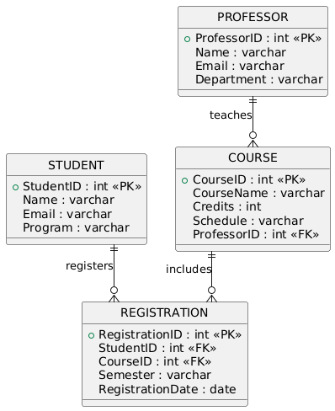

Below is PlantUML ERD code that identifies the database schema derived directly from the attached Level 1 DFD (Course Database + Registration Database).
This ERD models the data needed to support:
- Manage Courses
- Register for Course
- Generate Timetable

How This ERD Matches the Level 1 DFD
From D1 Course Database
➡️ COURSE
➡️ Linked to PROFESSOR (who provides course details)
From D2 Registration Database
➡️ REGISTRATION
➡️ Links STUDENT and COURSE

Relationship Summary (Beginner-Friendly)
- One Professor can teach many Courses
- One Student can register for many Courses
- One Course can have many Students
- The REGISTRATION table resolves the many-to-many relationship

One-Sentence Summary (Exam-Ready)
This ERD defines Student, Professor, Course, and Registration entities, where Registration links students and courses, supporting course management, registration, and timetable generation shown in the Level 1 DFD.

VS CODE:

using the attached ERD, write the VS code CREATE TABLE SQL statement for the corresponding table(s) that would be needed to implement that store.
Below are clean, VS Code–ready SQL CREATE TABLE statements that implement the database schema shown in your ERD.
These statements follow:
- Correct primary keys
- Proper foreign key constraints
- A logical creation order to avoid dependency errors

1️⃣ PROFESSOR Table
CREATE TABLE Professor (
ProfessorID INT PRIMARY KEY,
Name VARCHAR(100) NOT NULL,
Email VARCHAR(100) UNIQUE NOT NULL,
Department VARCHAR(100) NOT NULL
);

2️⃣ STUDENT Table
CREATE TABLE Student (
StudentID INT PRIMARY KEY,
Name VARCHAR(100) NOT NULL,
Email VARCHAR(100) UNIQUE NOT NULL,
Program VARCHAR(100) NOT NULL
);

3️⃣ COURSE Table
CREATE TABLE Course (
CourseID INT PRIMARY KEY,
CourseName VARCHAR(100) NOT NULL,
Credits INT NOT NULL,
Schedule VARCHAR(50) NOT NULL,
ProfessorID INT NOT NULL,
CONSTRAINT fk_course_professor
FOREIGN KEY (ProfessorID)
REFERENCES Professor(ProfessorID)
ON DELETE RESTRICT
);

4️⃣ REGISTRATION Table
CREATE TABLE Registration (
RegistrationID INT PRIMARY KEY,
StudentID INT NOT NULL,
CourseID INT NOT NULL,
Semester VARCHAR(20) NOT NULL,
RegistrationDate DATE NOT NULL,
CONSTRAINT fk_registration_student
FOREIGN KEY (StudentID)
REFERENCES Student(StudentID)
ON DELETE CASCADE,
CONSTRAINT fk_registration_course
FOREIGN KEY (CourseID)
REFERENCES Course(CourseID)
ON DELETE CASCADE,
CONSTRAINT uq_student_course
UNIQUE (StudentID, CourseID, Semester)
);

5️⃣ Correct Table Creation Order (IMPORTANT)
Run the SQL in this order:
1. Professor
2. Student
3. Course
4. Registration
This avoids foreign key reference errors.

6️⃣ How This Matches the ERD
ERD Relationship | SQL Implementation
Professor teaches Course | Course.ProfessorID → Professor.ProfessorID
Student registers Course | Registration.StudentID → Student.StudentID
Course includes Students | Registration.CourseID → Course.CourseID
Many-to-many resolved | Registration junction table

7️⃣ Optional Enhancements (Not Required but Good Practice)
If allowed, you may add auto-increment:
ProfessorID INT AUTO_INCREMENT
StudentID INT AUTO_INCREMENT
CourseID INT AUTO_INCREMENT
RegistrationID INT AUTO_INCREMENT

One-Sentence Summary (Exam-Ready)
These SQL CREATE TABLE statements implement the ERD by defining Professor, Student, Course, and Registration tables with appropriate primary keys and foreign key relationships.

CREATE TABLE Professor (
ProfessorID INT PRIMARY KEY,
Name VARCHAR(100) NOT NULL,
Email VARCHAR(100) UNIQUE NOT NULL,
Department VARCHAR(100) NOT NULL
);
CREATE TABLE Student_1 (
StudentID INT PRIMARY KEY,
Name VARCHAR(100) NOT NULL,
Email VARCHAR(100) UNIQUE NOT NULL,
Program VARCHAR(100) NOT NULL
);
CREATE TABLE Course (
CourseID INT PRIMARY KEY,
CourseName VARCHAR(100) NOT NULL,
Credits INT NOT NULL,
Schedule VARCHAR(50) NOT NULL,
ProfessorID INT NOT NULL,
CONSTRAINT fk_course_professor
FOREIGN KEY (ProfessorID)
REFERENCES Professor(ProfessorID)
ON DELETE RESTRICT
);
CREATE TABLE Registration (
RegistrationID INT PRIMARY KEY,
StudentID INT NOT NULL,
CourseID INT NOT NULL,
Semester VARCHAR(20) NOT NULL,
RegistrationDate DATE NOT NULL,
CONSTRAINT fk_registration_student
FOREIGN KEY (StudentID)
REFERENCES Student(StudentID)
ON DELETE CASCADE,
CONSTRAINT fk_registration_course
FOREIGN KEY (CourseID)
REFERENCES Course(CourseID)
ON DELETE CASCADE,
CONSTRAINT uq_student_course
UNIQUE (StudentID, CourseID, Semester)
);

INSERT INTO Professor (ProfessorID, Name, Email, Department) VALUES
(1, 'Dr. Alice Smith', 'alice.smith@university.edu', 'Computer Science'),
(2, 'Dr. John Brown', 'john.brown@university.edu', 'Information Systems');

INSERT INTO Student_1 (StudentID, Name, Email, Program) VALUES
(101, 'Emma Johnson', 'emma.johnson@student.edu', 'BSc Computer Science'),
(102, 'Liam Williams', 'liam.williams@student.edu', 'BSc Information Technology');
INSERT INTO Course (CourseID, CourseName, Credits, Schedule, ProfessorID) VALUES
(1001, 'Database Systems', 3, 'Mon 10:00–12:00', 1),
(1002, 'Software Engineering', 4, 'Wed 14:00–17:00', 2);
INSERT INTO Registration (RegistrationID, StudentID, CourseID, Semester, RegistrationDate) VALUES
(5001, 101, 1001, 'Fall 2025', '2025-08-20'),
(5002, 101, 1002, 'Fall 2025', '2025-08-21'),
(5003, 102, 1001, 'Fall 2025', '2025-08-22');

select * from Professor;
select * from Student_1;
select * from Course;
select * from Registration;

